Task on CloudFront
- Configure VPC peering in cross regions.
Step-by-Step Setup
- Create Two VPCs
  - Go to AWS console, create VPC 1 in Region A and VPC 2 in Region B.
  - Choose non-overlapping CIDR ranges (e.g., 10.0.0.0/16 and 10.1.0.0/16).
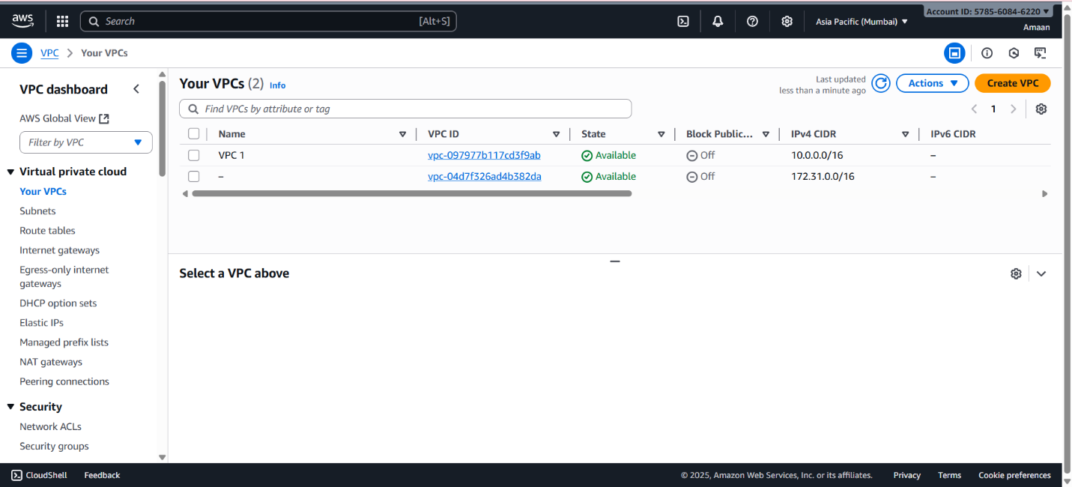
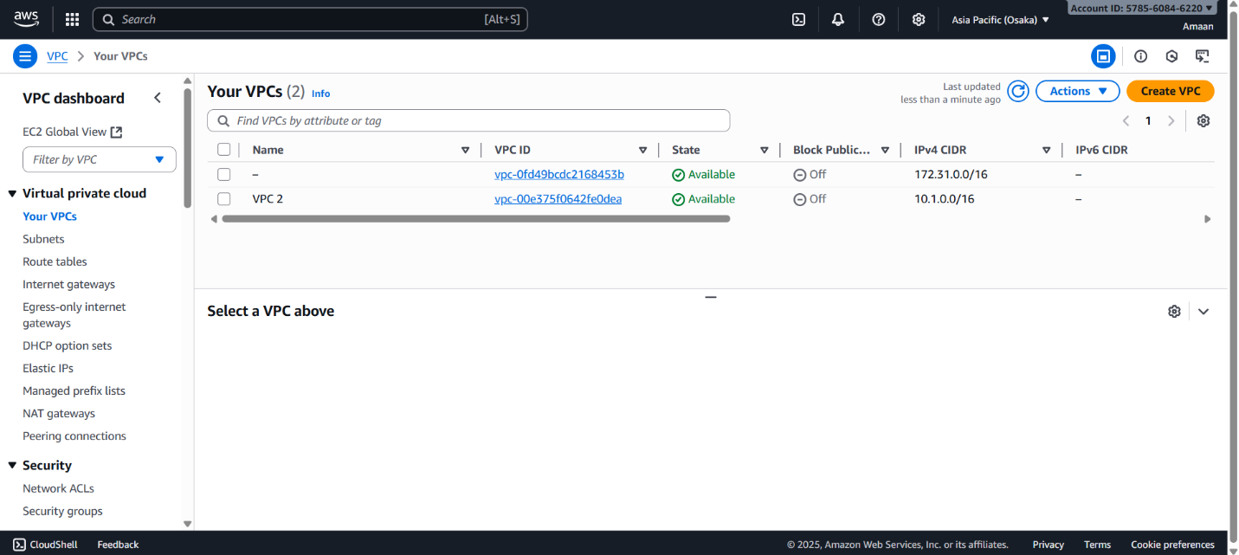

- Create Subnets
  - In each VPC, create at least one subnet for launching EC2 instances.
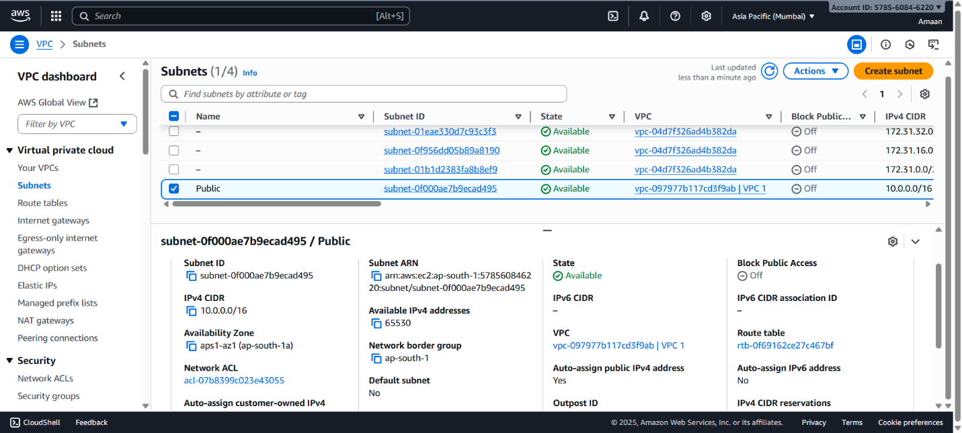
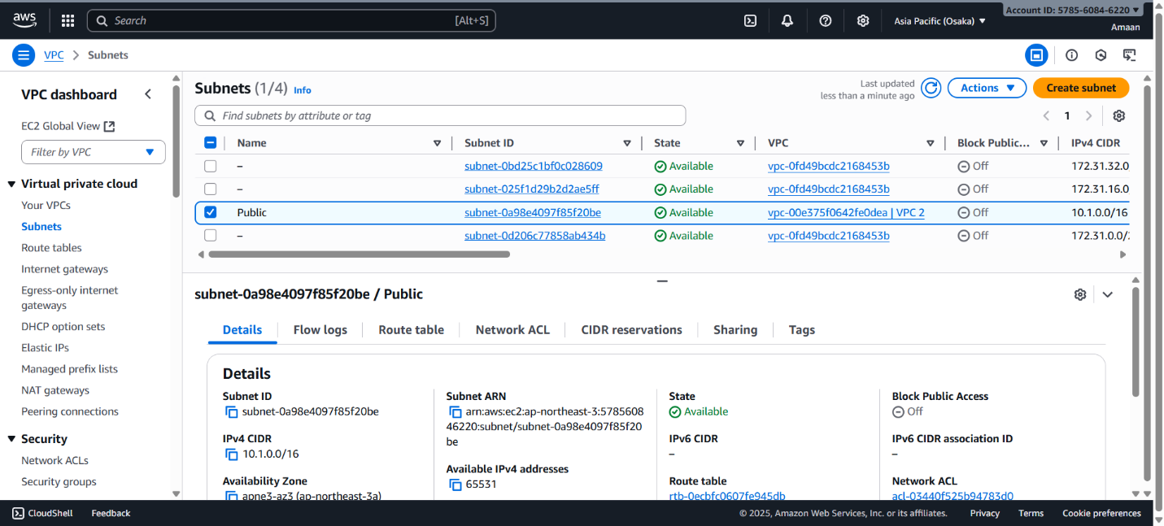

- Attach Internet Gateway
  - In at least one VPC (typically the primary), create and attach an internet gateway so resources can access the internet.
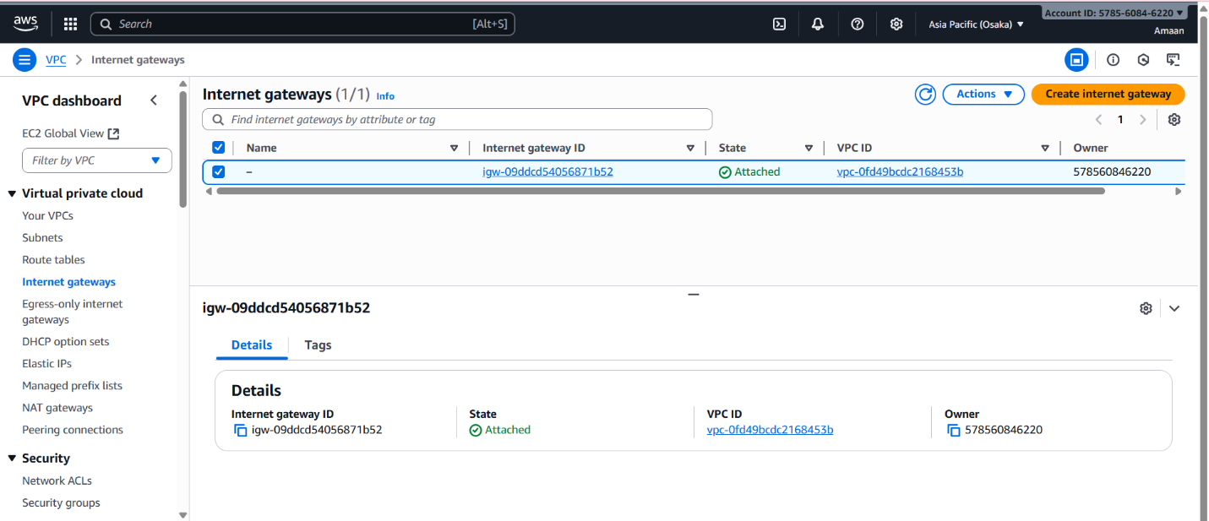
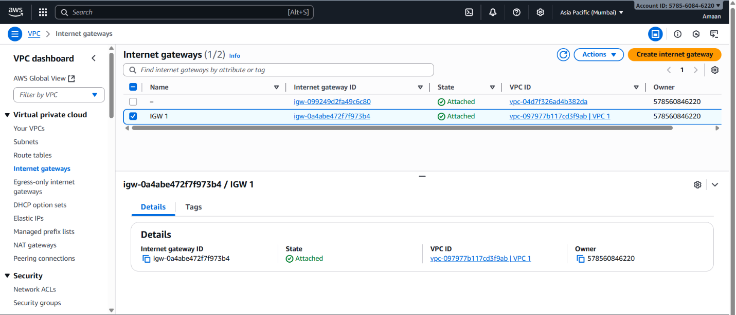

- Launch EC2 Instances
  - In each VPC, launch an EC2 instance in the subnet created earlier.
  - Assign public IPs if you need internet access, and set up security groups to allow ping (ICMP) traffic.
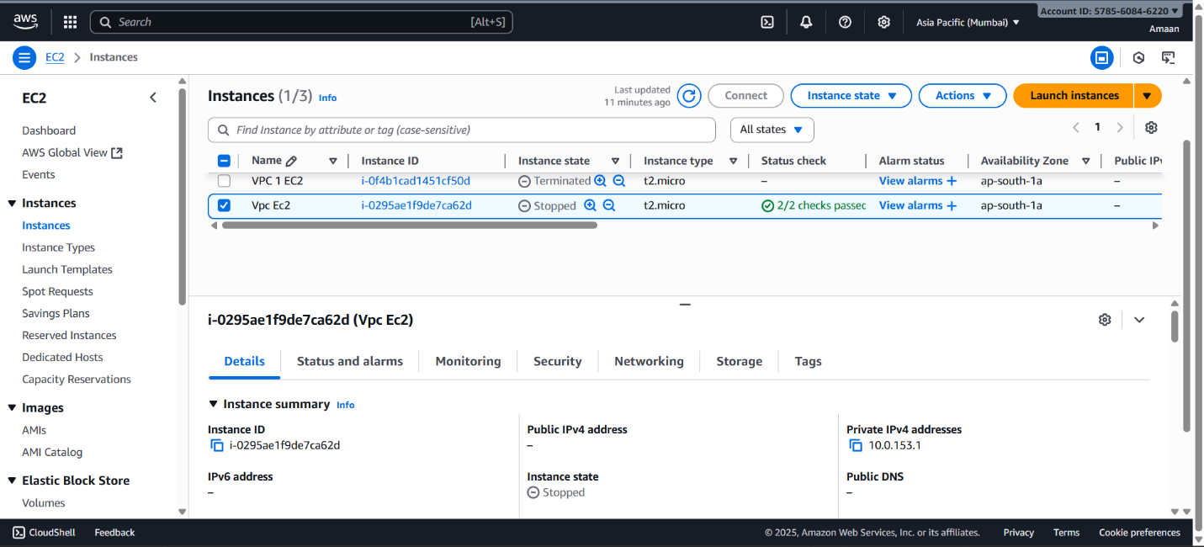
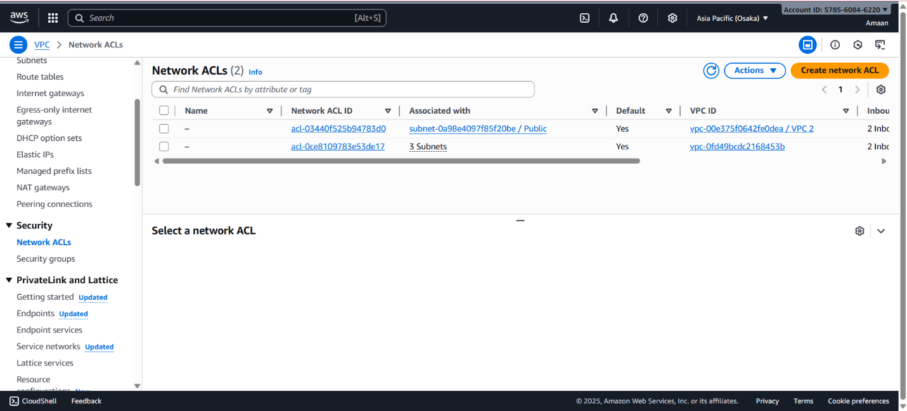
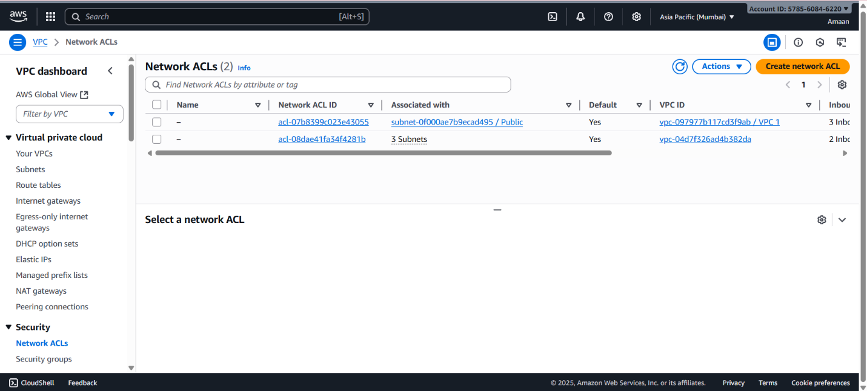
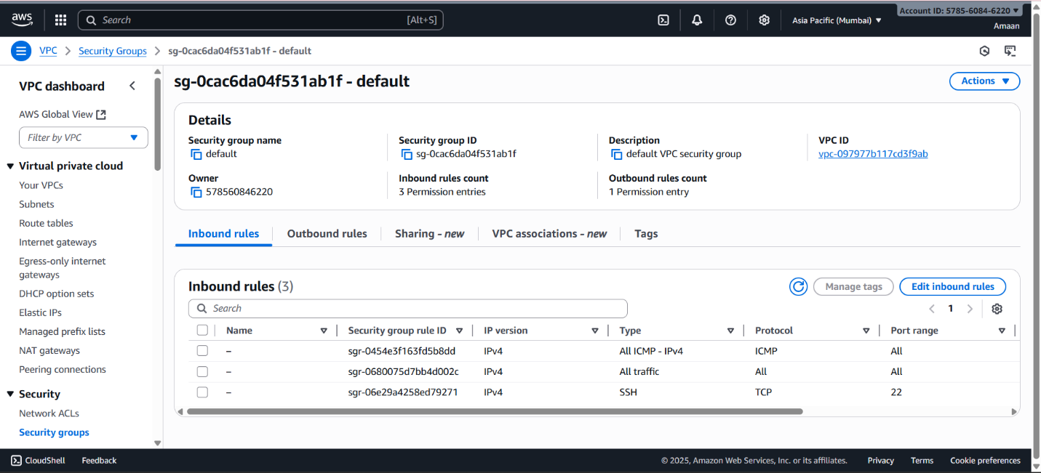

- Create VPC Peering Connection
  - From VPC 1 in Region A, initiate a VPC peering connection targeting VPC 2 in Region B.
  - In the AWS console for Region B, accept the peering connection request.
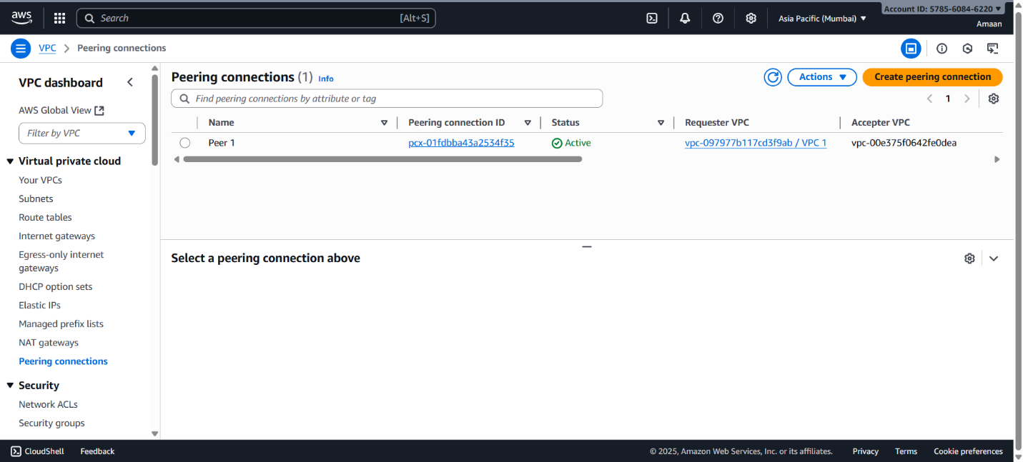
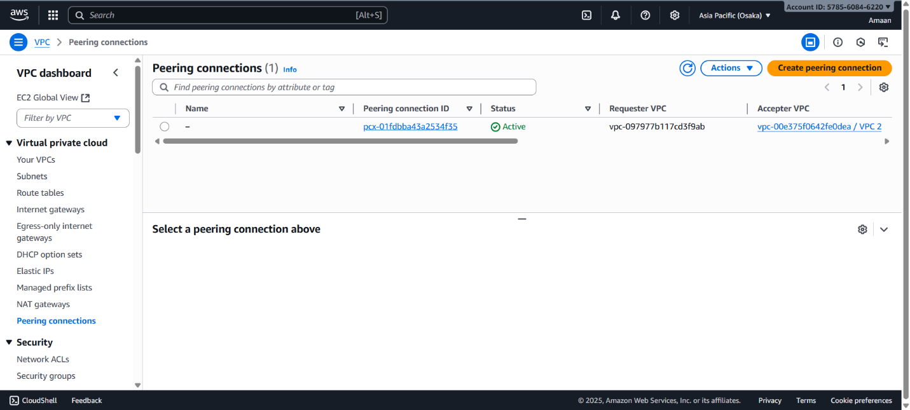

- Update Route Tables
  - In each VPC, add a route to the other VPC’s CIDR block using the peering connection as the next hop.
  - This allows private communication between VPCs.
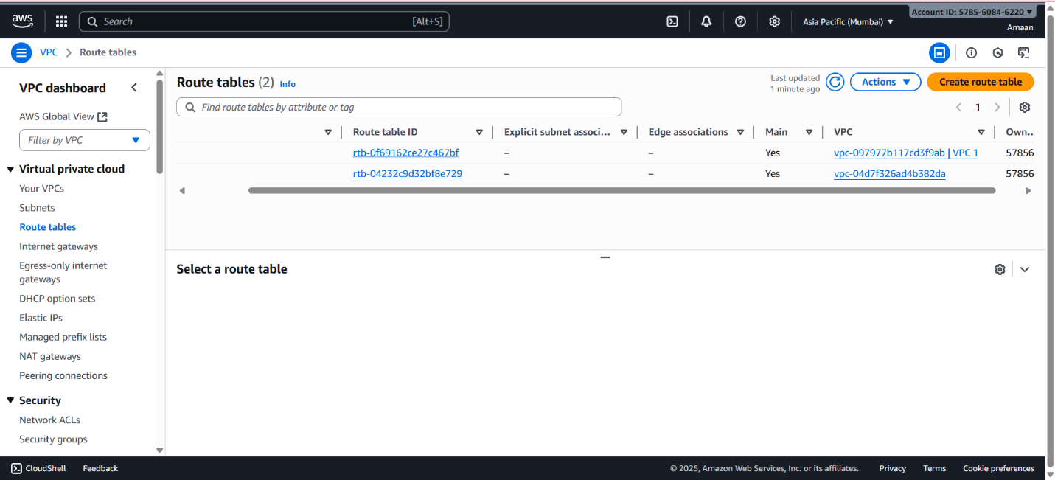
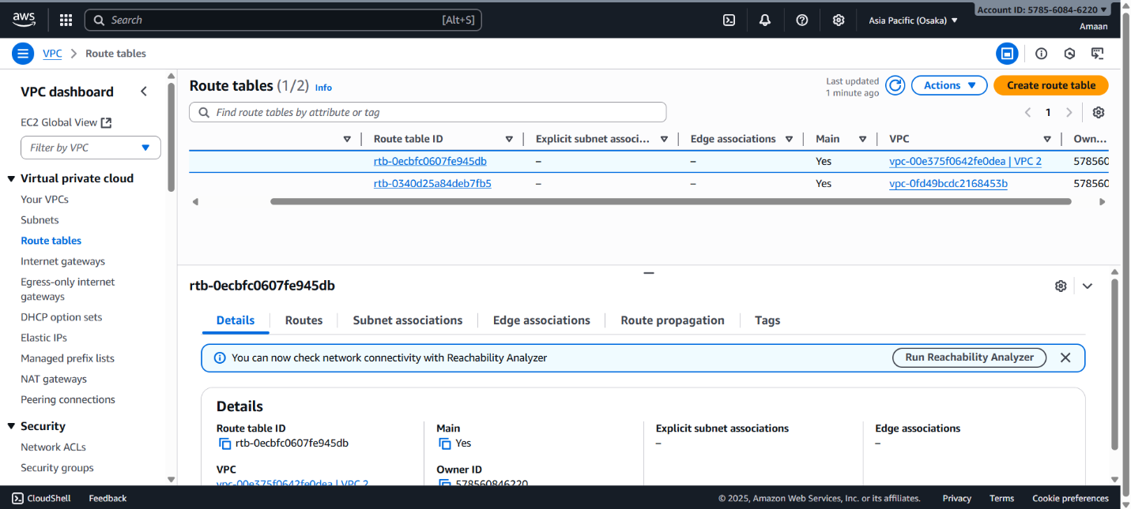

- Test Connectivity
  - SSH into one EC2 instance and ping the private IP of the EC2 in the other VPC.
  - Ping should work if everything is set up correctly.

2) Purchase one domain from godaddy.
The steps to purchase one domain from GoDaddy from the document are:
- Go to GoDaddy's website.
- Search for the desired domain name.
- Select the domain and add it to the cart.
- Proceed to checkout and complete the purchase by providing the required details and payment.
This is a simple domain purchase procedure.
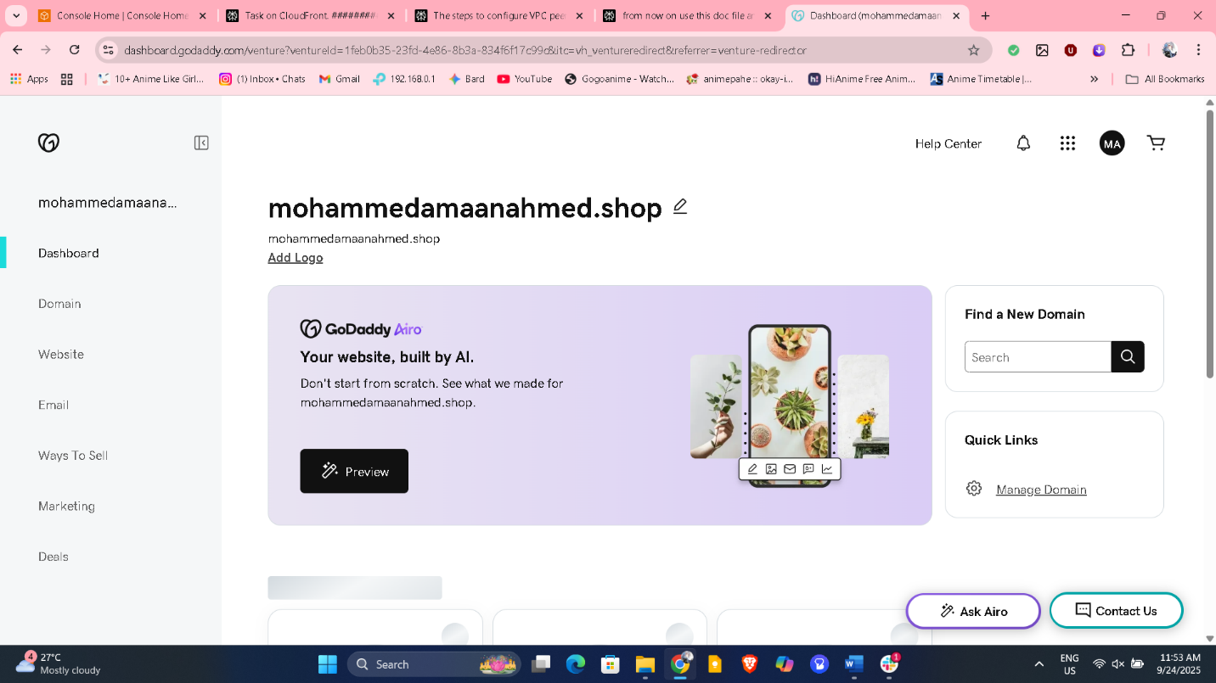

3) Deploy static webiste in s3.
The steps to deploy a static website in S3 from the document are:
- Upload website files to an S3 bucket.
  - Go to S3 → Buckets → Select the bucket → Objects → Upload → Add website files → Upload.
- Make the uploaded files public.
  - Select the files → Actions → Make public using ACL.
- Enable static website hosting on the S3 bucket.
  - Go to S3 → Buckets → Select the bucket → Properties → Static website hosting → Enable.
  - Set index and error documents → Save changes.
- After enabling static website hosting, a URL will be generated for the website.

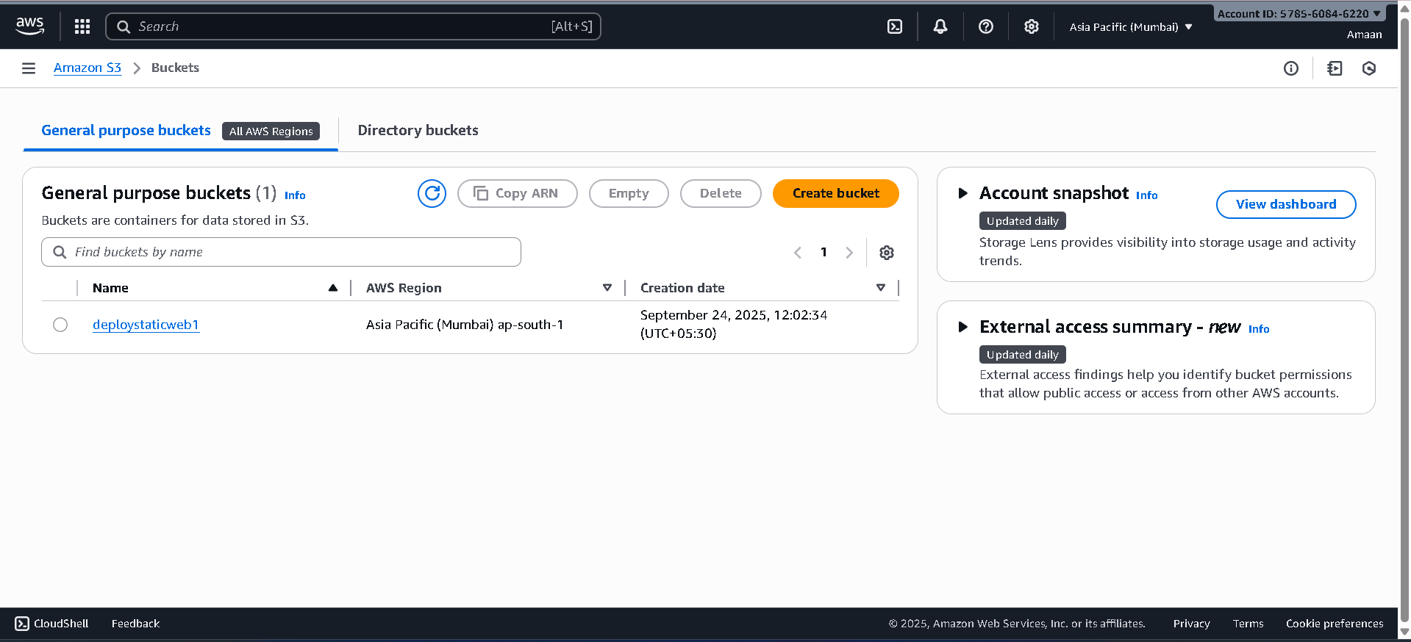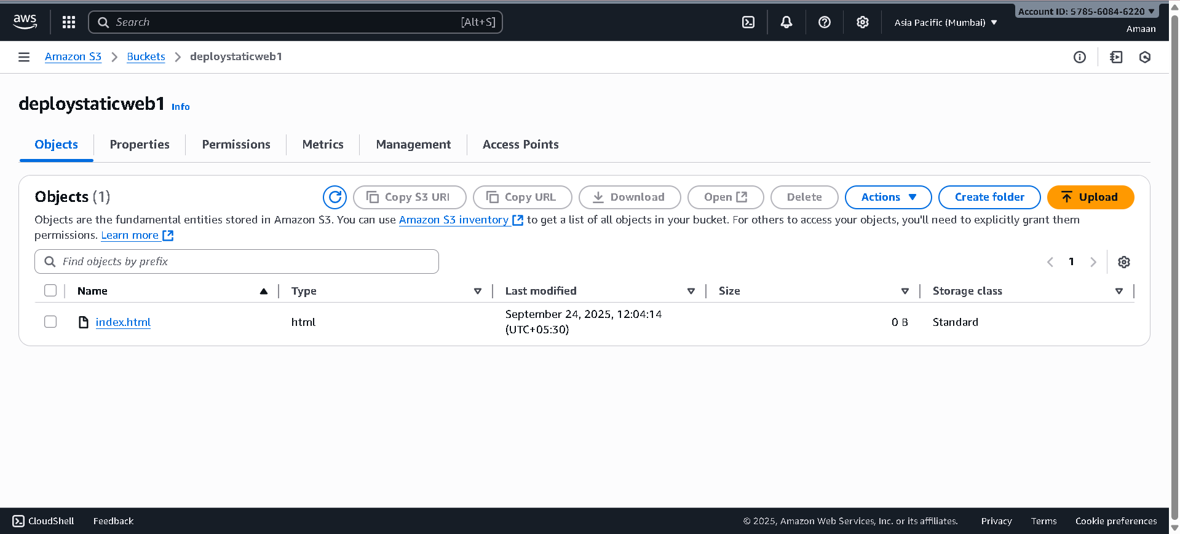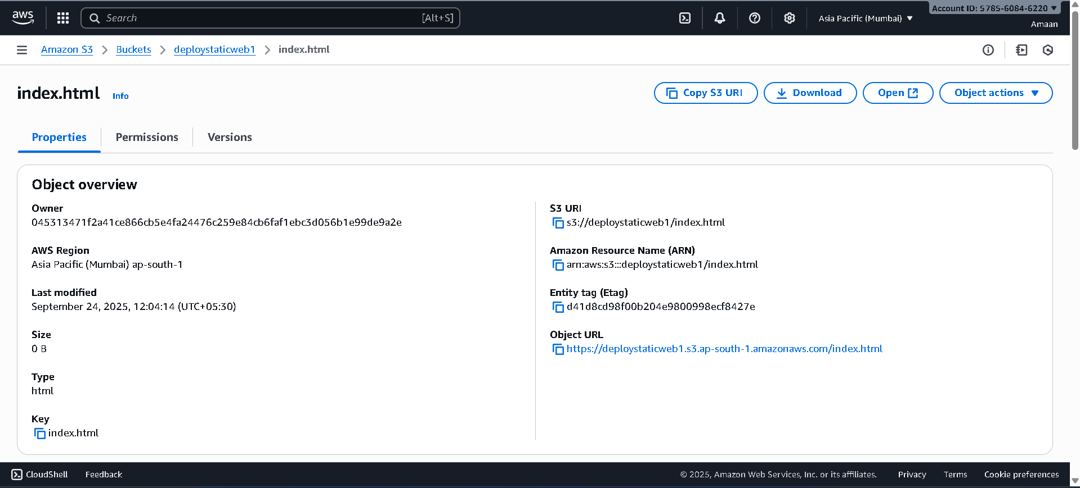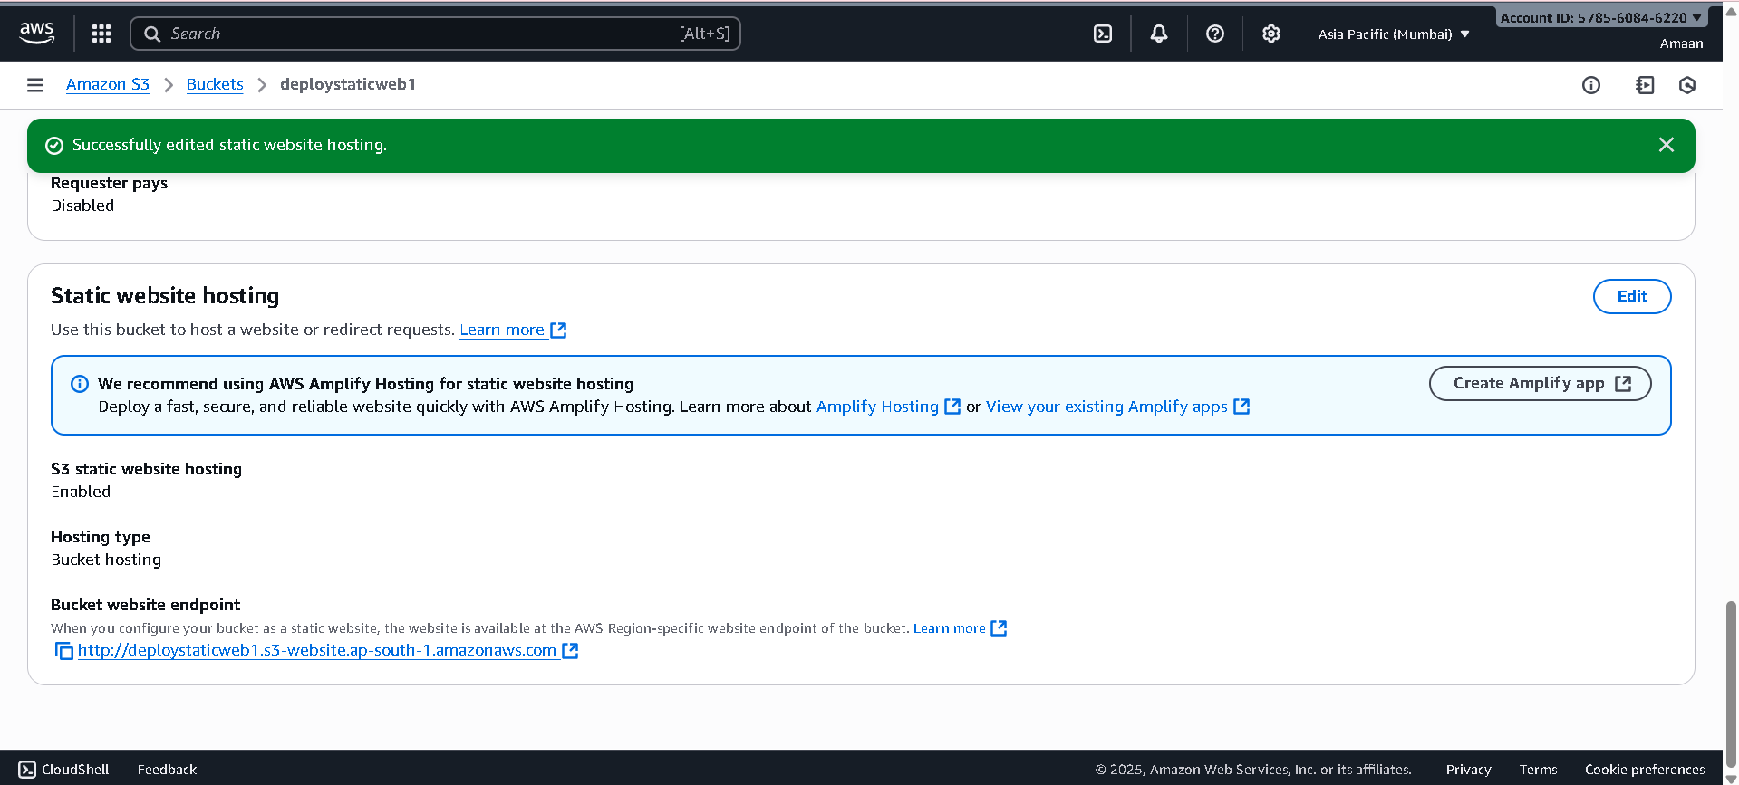
4) Create CDN and attach one SSL certificate.
The steps to create a CDN (CloudFront distribution) and attach an SSL certificate from the document are:
- Create a CloudFront Distribution:
  - Go to CloudFront → Distributions → Create distribution.
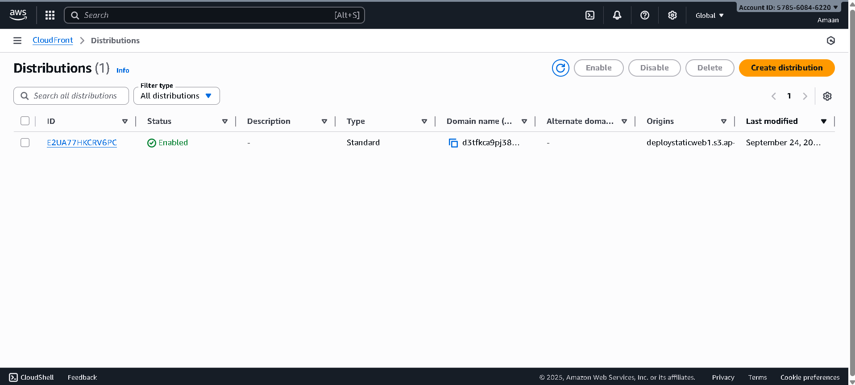
- Attach SSL Certificate:
  - Go to CloudFront → Distributions → Select the created distribution → Edit settings.
  - Click "Request certificates" to request an SSL certificate.
  - Once requested, the certificate status may show "pending validation" with a CNAME record.
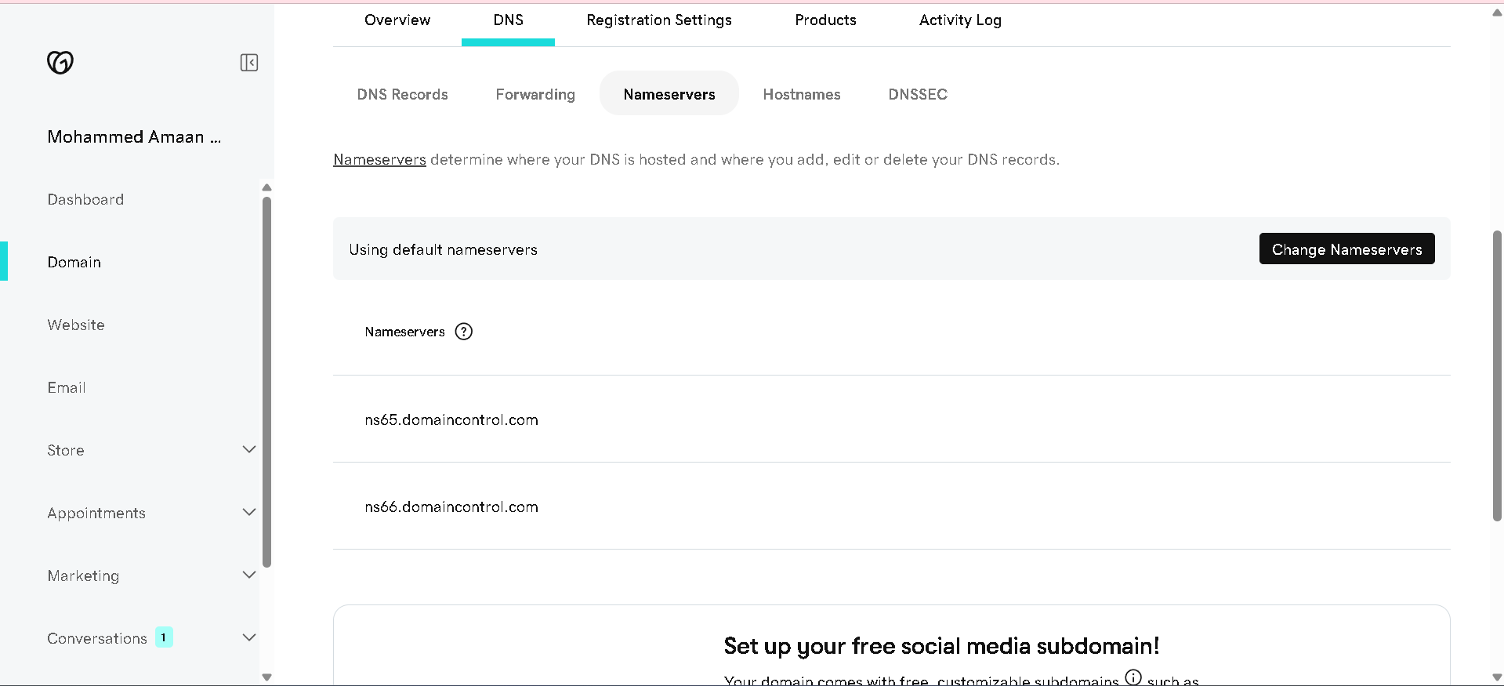
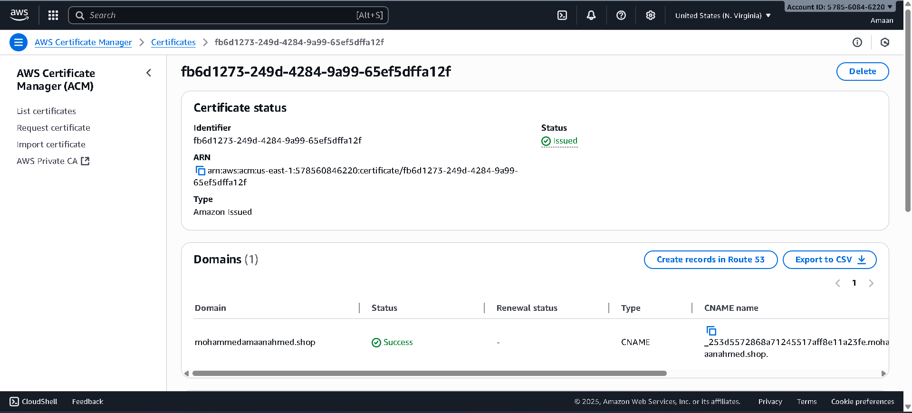
- Validate SSL Certificate:
  - Add the provided CNAME record in Route 53 (or your DNS service) to validate the certificate.
  - In Route 53, go to Hosted Zones → Select your domain → Create a record with the CNAME details provided by the certificate request.
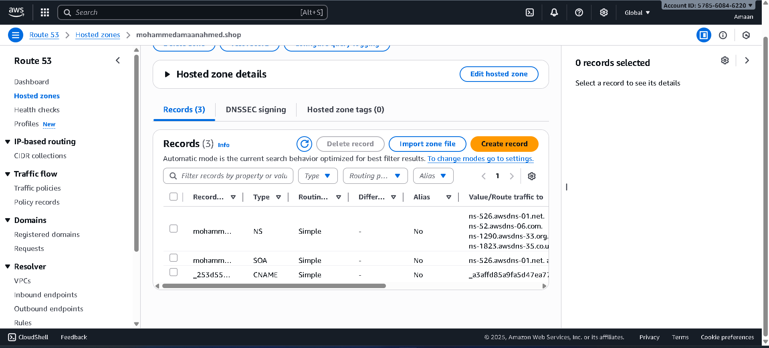
- Once validated, SSL certificate will be attached to CloudFront distribution.
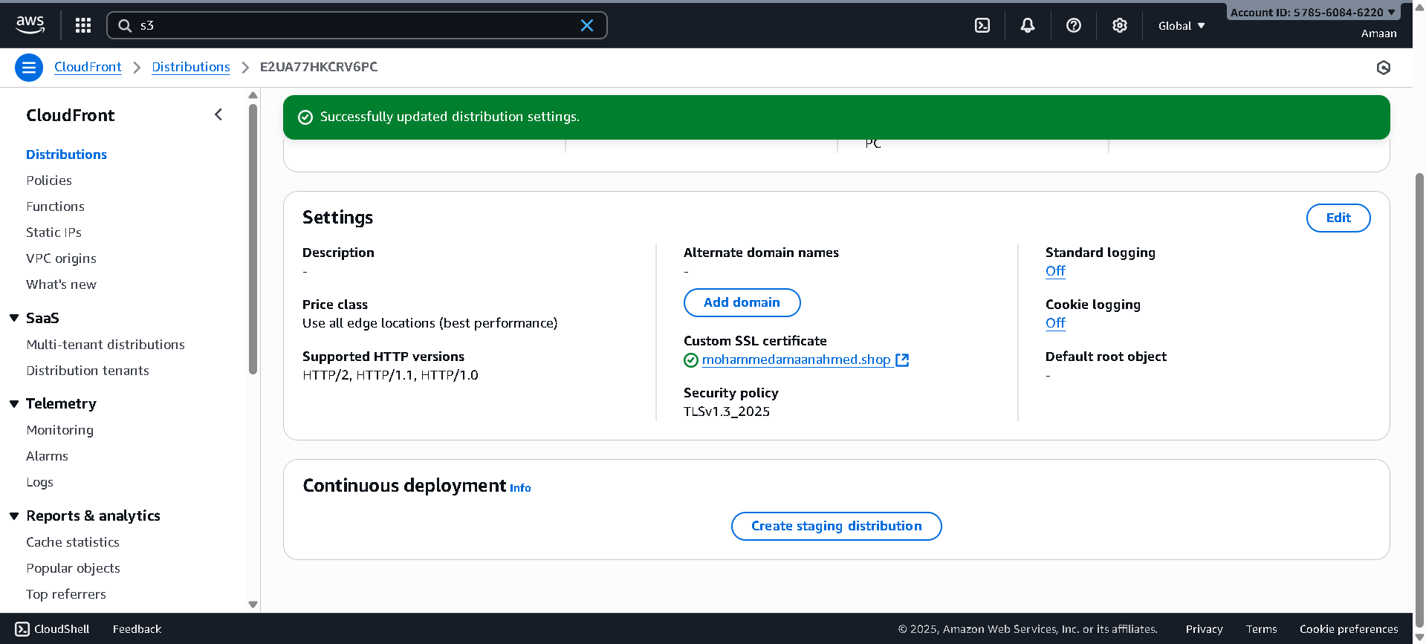

5) Create Route53 hosted zone and MAP the domain with CDN.
The steps to create a Route53 hosted zone and map the domain with the CDN from the document are:
- Create Route53 Hosted Zone:
  - Go to Route53 → Hosted zones → Create hosted zone.
  - Enter the domain name (e.g., krsnaco.shop) and click Create hosted zone.

- Update Nameservers in GoDaddy:
  - Copy the nameservers shown in the Route53 hosted zone (e.g., ns-428.awsdns-53.com, ns-1595.awsdns-07.co.uk, etc.).
  - Go to GoDaddy → My Products → Select your domain → Manage domain → DNS → Nameservers → Change Nameservers → Choose "I’ll use my own nameservers."
  - Add the Route53 nameservers and save.
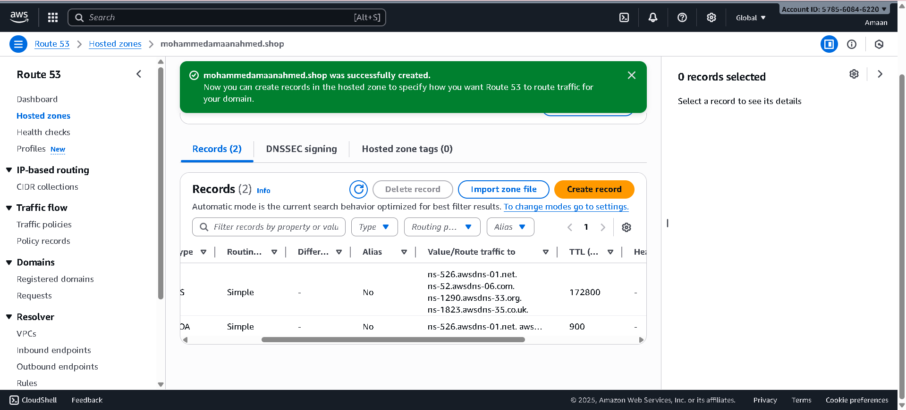
- Map Domain with CDN:
  - In Route53, create an alias record pointing the domain to the CloudFront distribution to map the domain with the CDN.

6) Update the index.html in s3 bucket and the updated file should be accessible by using domain name.
7) Share the Domain name in slack to test the connetivity.
mohammedamaanahmed.shop

